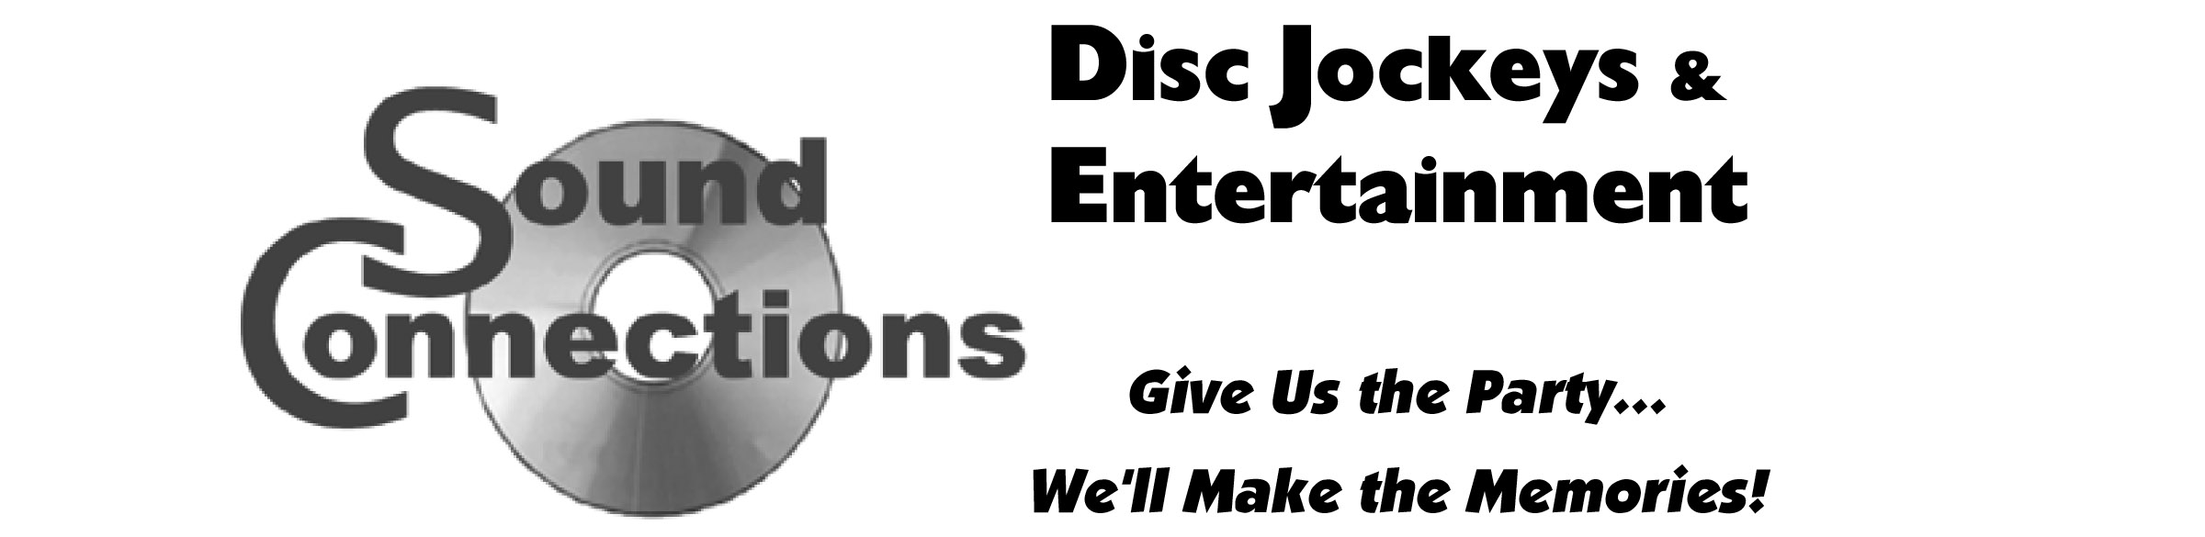

5200 WEST Loop South, Suite 207, Bellaire, TX 77401 - (713) 641-6263 office - (713) 661-2218 fax – www.SoundConnectionsInc.com

LIGHT SHOW SELECTIONS
To further enhance your event, we offer customized Light Show selections
at additional charges (for entire event). Please review this list and select which Light Show you prefer.
Note your selection and additional fee on your contract, and include your extra fee with payment.

STANDARD LIGHT SHOWS (five selections to choose from):

LIGHT SHOW #1 – “A CLASS ACT” --- $100 additional charge includes:
Laser Effect Light
Agressor (LED colored lights move side to side to music)
Vertigo (LED colored lights move up & down to music)
Fog Machine OR Bubble Machine (your selection)
Light Board

LIGHT SHOW #2 – “SHAKE IT UP” --- $150 additional charge includes:
Laser Effect Light
Agressor (LED colored lights move side to side to music)
Vertigo (LED colored lights move up & down to music)
Fog Machine OR Bubble Machine
Strobe Light
Light Board

LIGHT SHOW #3 – “THE WILD THING” --- $200 additional charge includes:
Laser Effect Light
Agressor (LED colored lights move side to side to music)
Vertigo (LED colored lights move up & down to music)
Fog Machine
Bubble Machine
Strobe Light
Light Board

LIGHT SHOW #4 – “GET UP AND DANCE” --- $250 additional charge includes:
Laser Effect Light
Agressor (LED colored lights move side to side to music)
Vertigo (LED colored lights move up & down to music)
Fog Machine
Bubble Machine
Strobe Light
3 Laser Effect Lights (dual colored, multi patterned effects)
Light Board

DELUXE LIGHT SHOW – “BLOW OUT THE DOORS” --- $500 additional charge includes:
Laser Effect Light
Agressor (colored lights move side to side to music)
Fog Machine
Bubble Machine
Strobe Light
3 Laser Effect Lights (dual colored, multi patterned effects)
Light Board
Centerpiece
12 foot Truss

